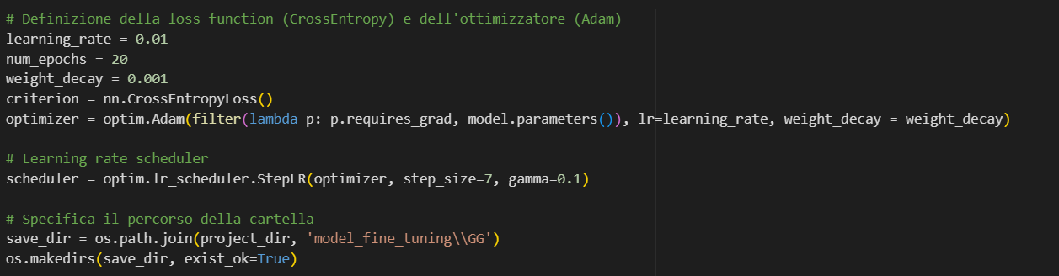

Batch =32

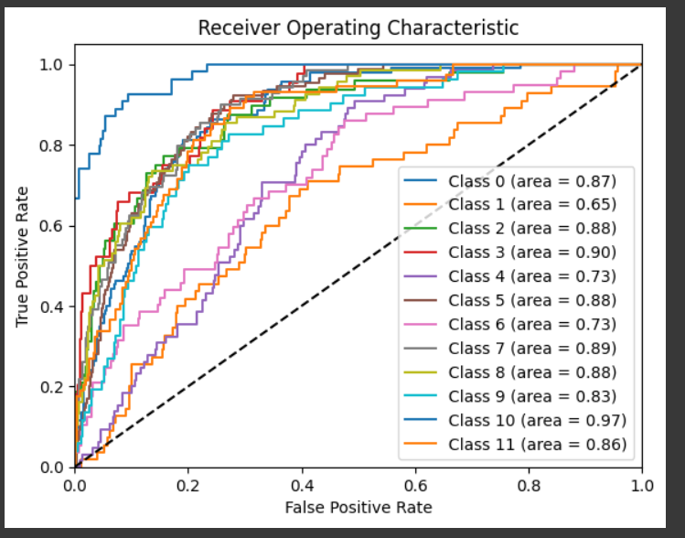

Epoch 1/20

----------

train Loss: 2.7338, Acc: 0.1591, F1: 0.1500

test Loss: 2.4960, Acc: 0.1221, F1: 0.0347

Validation loss decreased (inf --> 2.495985). Saving model ...

Epoch 2/20

----------

train Loss: 2.6753, Acc: 0.1891, F1: 0.1724

test Loss: 2.3466, Acc: 0.1571, F1: 0.0797

Validation loss decreased (2.495985 --> 2.346587). Saving model ...

Epoch 3/20

----------

train Loss: 2.4665, Acc: 0.2038, F1: 0.1852

test Loss: 2.2628, Acc: 0.2130, F1: 0.1424

Validation loss decreased (2.346587 --> 2.262821). Saving model ...

Epoch 4/20

----------

train Loss: 2.5018, Acc: 0.2027, F1: 0.1833

test Loss: 2.3623, Acc: 0.1961, F1: 0.1464

EarlyStopping counter: 1 out of 7

Epoch 5/20

----------

train Loss: 2.2381, Acc: 0.2485, F1: 0.2314

test Loss: 2.1294, Acc: 0.2805, F1: 0.2130

Validation loss decreased (2.262821 --> 2.129448). Saving model ...

Epoch 6/20

----------

train Loss: 2.0992, Acc: 0.2877, F1: 0.2635

test Loss: 1.9852, Acc: 0.2805, F1: 0.2223

Validation loss decreased (2.129448 --> 1.985210). Saving model ...

Epoch 7/20

----------

train Loss: 2.0015, Acc: 0.2834, F1: 0.2687

test Loss: 1.9627, Acc: 0.3091, F1: 0.2670

Validation loss decreased (1.985210 --> 1.962745). Saving model ...

Epoch 8/20

----------

train Loss: 1.8757, Acc: 0.3270, F1: 0.3069

test Loss: 1.8447, Acc: 0.3195, F1: 0.2818

Validation loss decreased (1.962745 --> 1.844672). Saving model ...

Epoch 9/20

----------

train Loss: 1.7956, Acc: 0.3564, F1: 0.3321

test Loss: 1.8170, Acc: 0.3442, F1: 0.3192

Validation loss decreased (1.844672 --> 1.817021). Saving model ...

Epoch 10/20

----------

train Loss: 1.7612, Acc: 0.3749, F1: 0.3551

test Loss: 1.7982, Acc: 0.3403, F1: 0.3035

Validation loss decreased (1.817021 --> 1.798228). Saving model ...

Epoch 11/20

----------

train Loss: 1.6984, Acc: 0.3924, F1: 0.3691

test Loss: 1.7742, Acc: 0.3597, F1: 0.3381

Validation loss decreased (1.798228 --> 1.774189). Saving model ...

Epoch 12/20

----------

train Loss: 1.6638, Acc: 0.4098, F1: 0.3881

test Loss: 1.7348, Acc: 0.3779, F1: 0.3540

Validation loss decreased (1.774189 --> 1.734796). Saving model ...

Epoch 13/20

----------

train Loss: 1.6357, Acc: 0.4218, F1: 0.4013

test Loss: 1.7154, Acc: 0.3792, F1: 0.3639

Validation loss decreased (1.734796 --> 1.715416). Saving model ...

Epoch 14/20

----------

train Loss: 1.6165, Acc: 0.4354, F1: 0.4145

test Loss: 1.7385, Acc: 0.3714, F1: 0.3567

EarlyStopping counter: 1 out of 7

Epoch 15/20

----------

train Loss: 1.5790, Acc: 0.4458, F1: 0.4279

test Loss: 1.7119, Acc: 0.3987, F1: 0.3858

Validation loss decreased (1.715416 --> 1.711857). Saving model ...

Epoch 16/20

----------

train Loss: 1.5700, Acc: 0.4572, F1: 0.4402

test Loss: 1.6962, Acc: 0.4104, F1: 0.3932

Validation loss decreased (1.711857 --> 1.696182). Saving model ...

Epoch 17/20

----------

train Loss: 1.5464, Acc: 0.4545, F1: 0.4384

test Loss: 1.6928, Acc: 0.4104, F1: 0.3950

Validation loss decreased (1.696182 --> 1.692847). Saving model ...

Epoch 18/20

----------

train Loss: 1.5321, Acc: 0.4643, F1: 0.4431

test Loss: 1.6857, Acc: 0.4156, F1: 0.3981

Validation loss decreased (1.692847 --> 1.685675). Saving model ...

Epoch 19/20

----------

train Loss: 1.4758, Acc: 0.4801, F1: 0.4574

test Loss: 1.6838, Acc: 0.4104, F1: 0.3976

Validation loss decreased (1.685675 --> 1.683811). Saving model ...

Epoch 20/20

----------

train Loss: 1.5176, Acc: 0.4670, F1: 0.4499

test Loss: 1.6802, Acc: 0.4104, F1: 0.3937

Validation loss decreased (1.683811 --> 1.680242). Saving model ...